1 mostrar los actores y las películas en las que participan
SELECT a.first_name AS nombre, f.title AS pelicula
FROM actor a
INNER JOIN film_actor fa ON a.actor_id = fa.actor_id
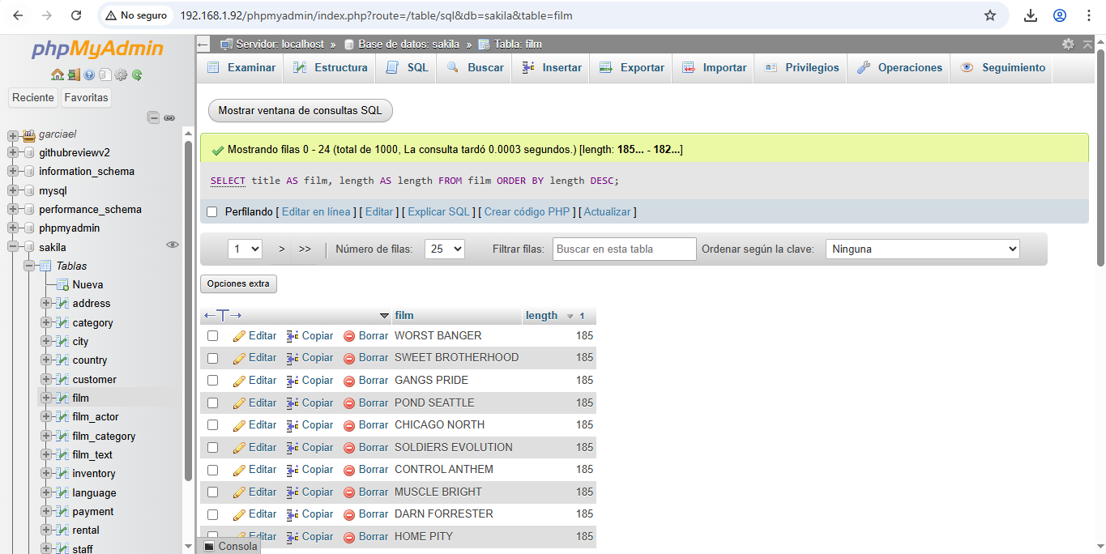
INNER JOIN film f ON fa.film_id=f.film_id;

2 mostrar las películas ordenadas de mayor a menor duración
SELECT title AS film, length AS length
FROM film
ORDER BY length DESC;
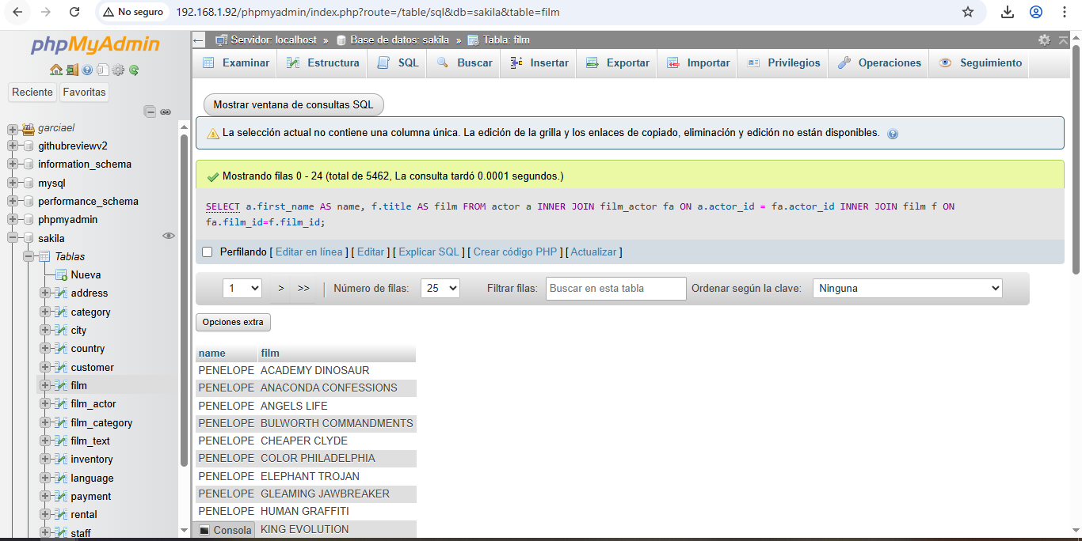

3 mostrar las películas que pertenecen a la categoría “action”
SELECT f.title AS película, c.name AS categoría
FROM film f
INNER JOIN film_category fc ON f.film_id = fc.film_id
INNER JOIN category c ON fc.category_id = c.category_id
WHERE c.name = ‘Action’;
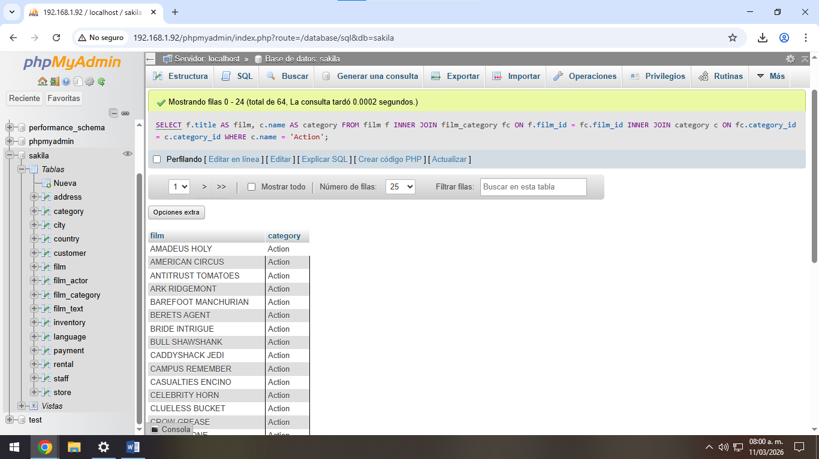

4 mostrar los clientes con la cantidad de rentas que ha realizado
SELECT c.first_name as first_name, c.last_name AS last_name, count(r.rental_id) AS total_rental
FROM customer c
INNER JOIN rental r ON c.customer = r.customer_id
GROUP BY c.customer_id, c.first_name, c.last_name; 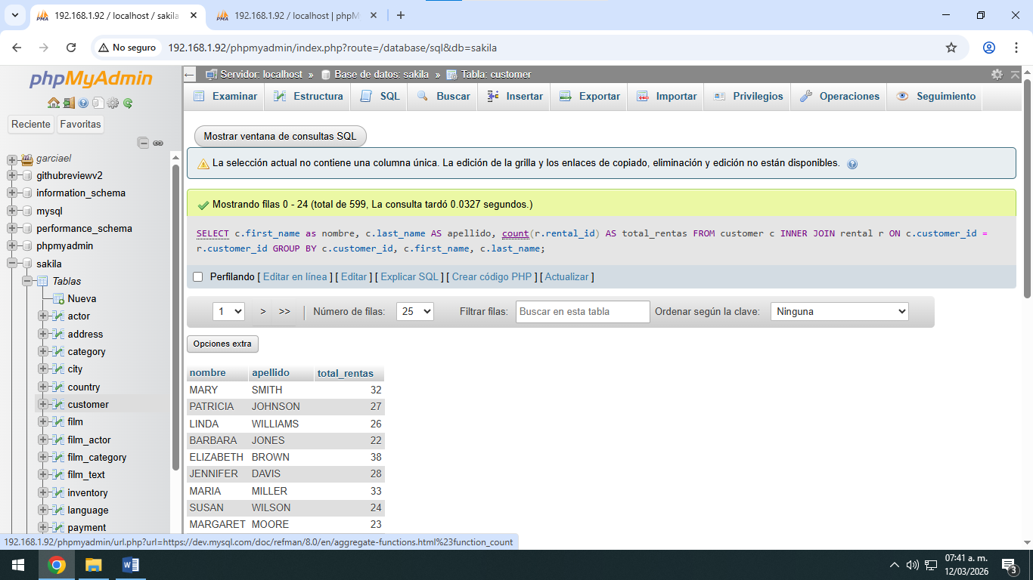

5 mostrar los pagos realizados por cada cliente
SELECT c.first_name AS nombre, c.last_name AS apellido, p.amount AS pago FROM customer c
INNER JOIN payment p ON c.customer_id = p.customer_id;
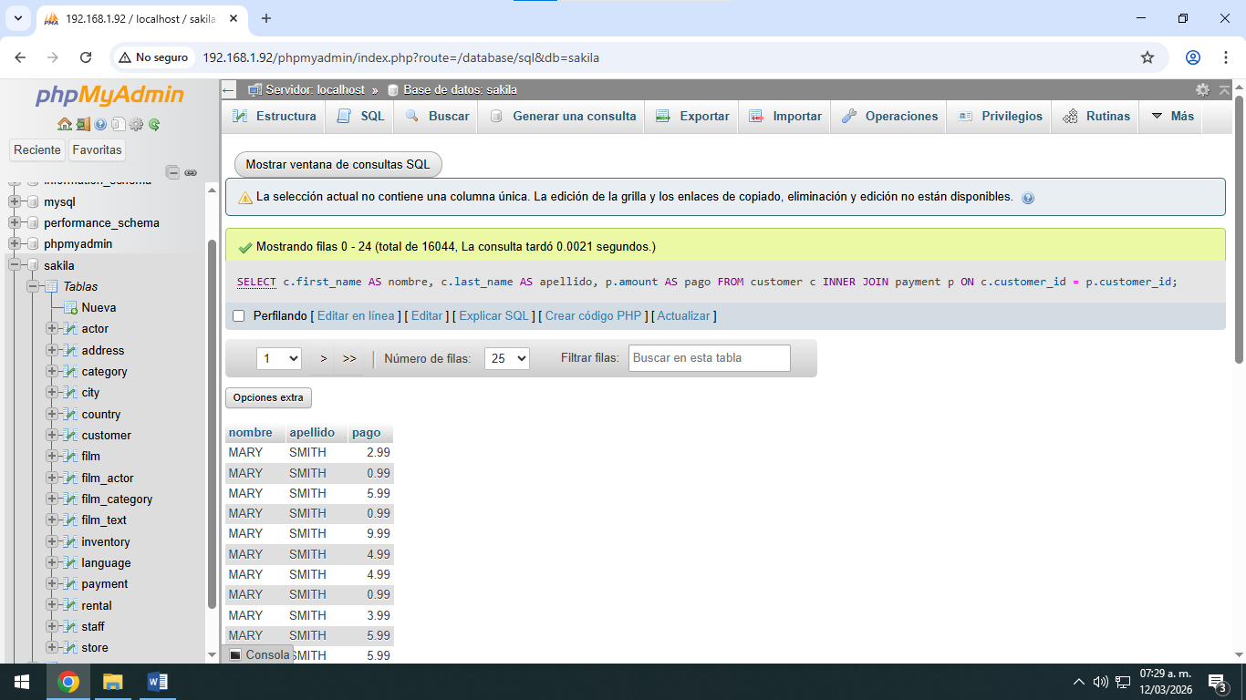

6 mostrar cuantos clientes hay por tienda
SELECT store_id AS tienda, count(customer_id) AS total_clientes
FROM customer
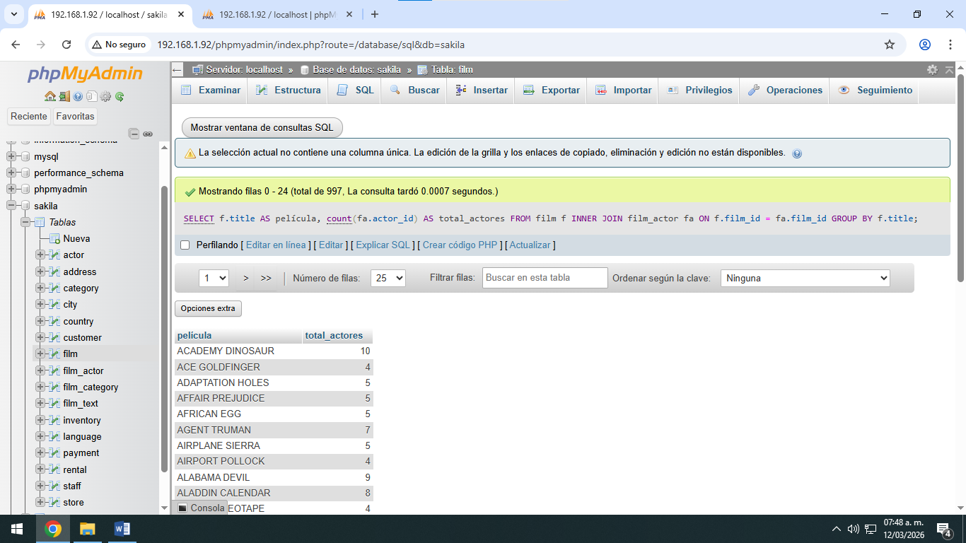
GROUP BY store_id;

7 contar cuantos actores hay en cada película
SELECT f.title AS película, count(fa.actor_id) AS total_actores
FROM film f
INNER JOIN film_actor fa ON f.film_id = fa.film_id
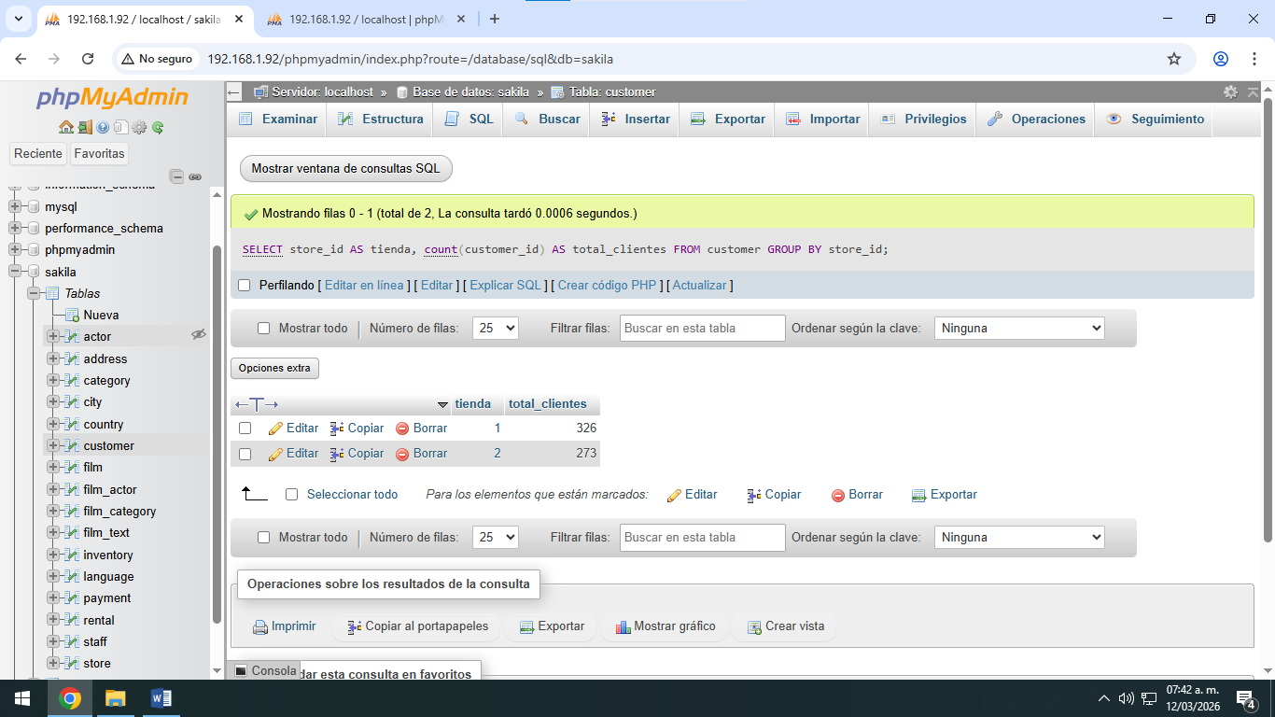
GROUP BY f.title;

8 mostrar las 5 películas más rentadas
SELECT f.title AS película, count(r.rental_id) AS total_rentas
FROM film f
INNER JOIN inventory i on f.film_id =i.film_id
INNER JOIN rental r ON i.inventory_id = r.inventory_id
GROUP BY f.film_id, f.title
ORDER BY total_rentas DESC
LIMIT 5;
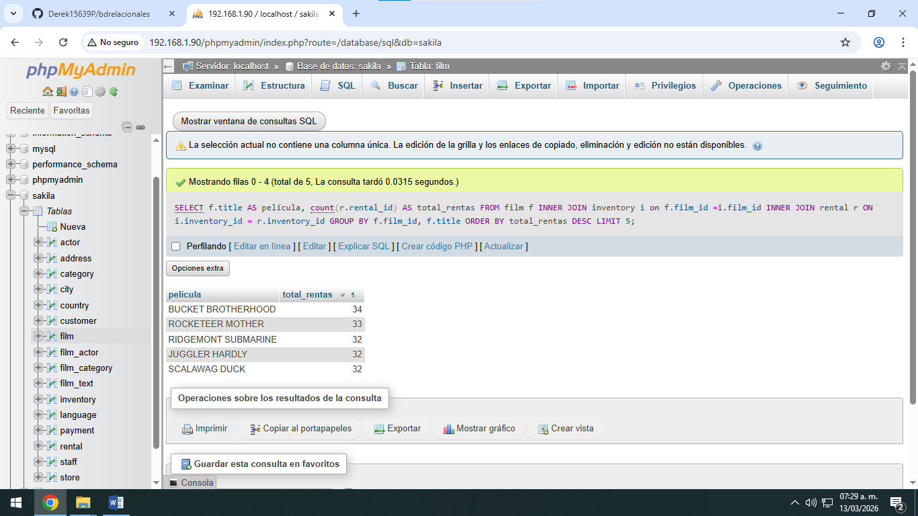

9 mostrar cuantas películas hay por idioma
SELECT l.name AS idioma, count(f.film_id) AS total_peliculas
FROM language l
INNER JOIN film f ON l.language_id = f.language_id
GROUP by l.name;
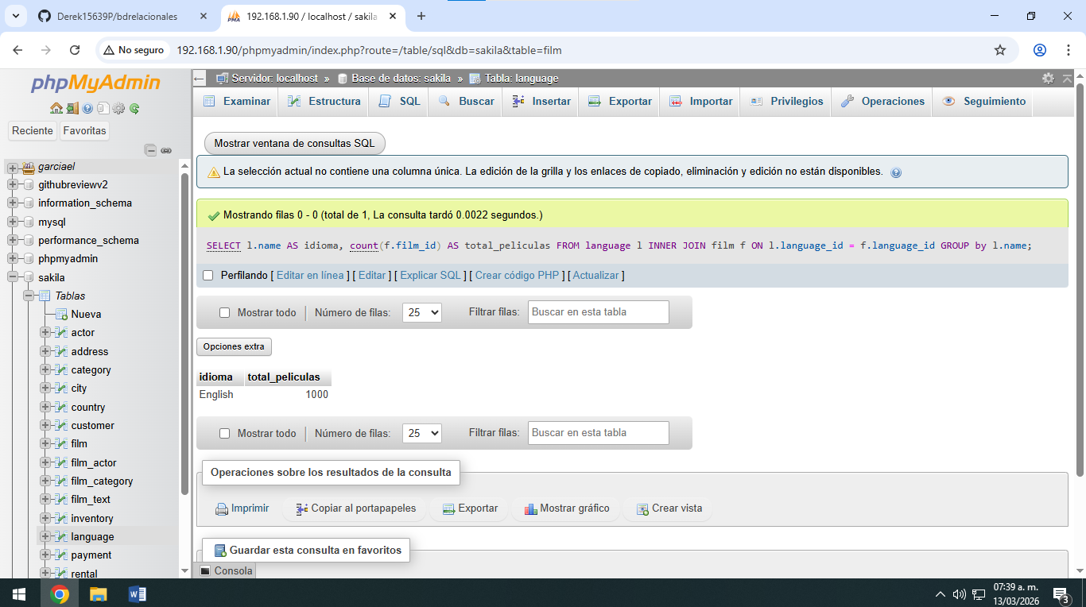
10 mostrar el total de rentas realizadas por cada tienda
SELECT s.store_id AS tienda, count(r.rental_id) AS total_rentas
FROM store s
INNER JOIN staff st ON s.store_id = st.store_id
INNER JOIN rental r ON st.staff_id = r.staff_id
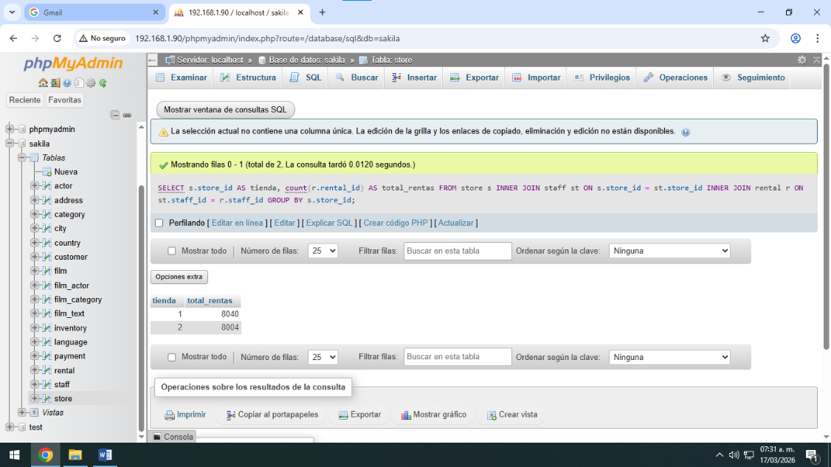
GROUP BY s.store_id

